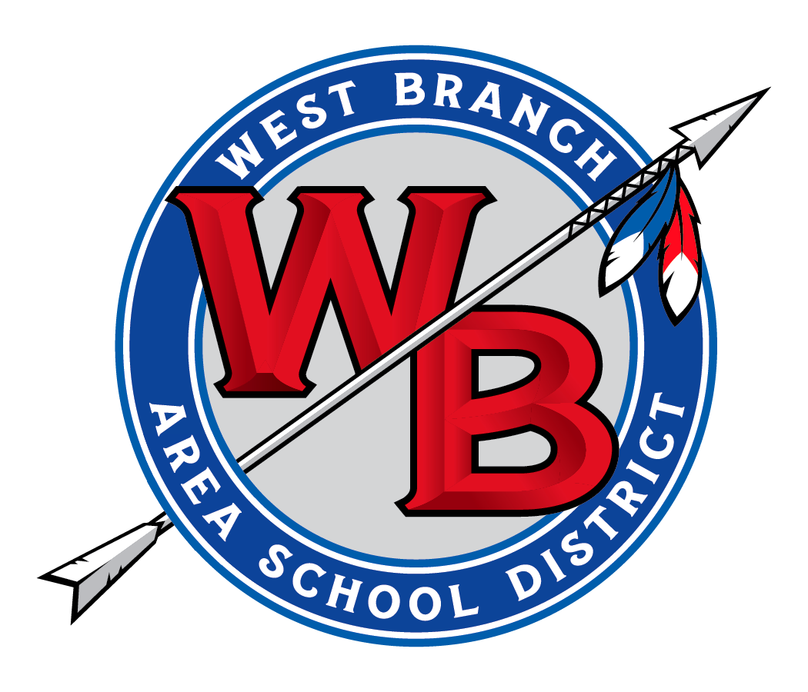
Erick L. Johnston
Business Manager
516 Allport Cutoff
Morrisdale PA, 16858
814.345.5615 x4850 814.345.5220
www.westbranch.org
Michelle Dutrow, Superintendent

WEST BRANCH AREA SCHOOL DISTRICT
516 Allport Cutoff, Morrisdale, PA 16858

AUTHORIZATION AGREEMENT FOR DIRECT DEPOSIT

I hereby authorize West Branch Area School District (Employer) hereinafter called Employer, to initiate Accounts Payable credit entries and to initiate, if necessary, debit entries and adjustments for any credit entries made in error to my bank account indicated below and authorize them to credit and/or debit the same to such account.

This direct deposit authorization is to remain in full force and effect until the Employer has received written notification from me of its termination at least two pay periods prior to revocation, allowing sufficient time for the Company to act upon my request. In like manner, the Employer will provide me with written notification of revocation of this direct deposit authorization at least two pay periods prior to termination.

Receiving Bank Name: _______________________________________________________________

Bank Address: ______________________________________________________________________

Bank Transit #: __________________________ Account #: __________________________________

Account Type (checking or savings): ____________________________________________________

Account Holder Name:_______________________________________________________________

Employee Name: __________________________________________________________________

Employee Address: _________________________________________________________________

Employee Email: ___________________________________________________________________

Employee Telephone #: ______________________________________________________________

Signature: ___________________________________________ Date: _________________________

Note: Please attach a voided check (or deposit ticket) to this form to verify bank transit and account number information.

The above-designated receiving financial institution will receive and deposit sums for the above-named payee in accordance with the NACHA (National Automated Clearing House Association) Rules and Guidelines. The financial institution reserves the right to cancel this agreement by notice to the payee.

