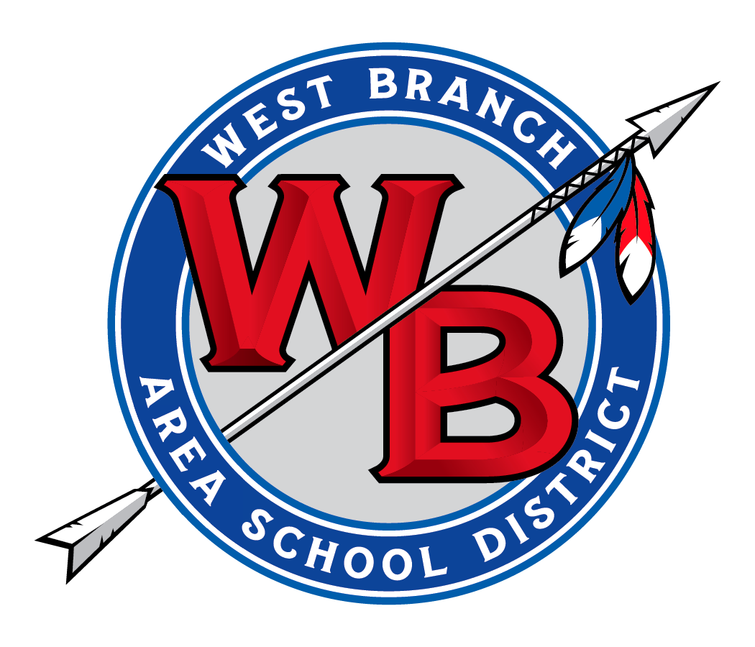**Joseph R. Holenchik**

High School Principal

516 Allport Cutoff

Morrisdale PA, 16858

814.345.5615x 1124 814.345.5220

[www.westbranch.org](http://www.westbranch.org/)

*Michelle Dutrow, Superintendent*

September 6, 2018

Dear Parents/Guardians:

The West Branch JHS is holding its annual open house on September 12, 2018 from 6:30 PM to 8:00 PM. This is an excellent opportunity for parents to meet their children’s teachers and ask any questions that they might have regarding our school programs. Teachers will be available in their classrooms to meet and talk with parents. The guidance counselors and principal will also be available to answer any questions or provide information.

On November 8, 2018, there will be a parent/teacher conference night. By appointment, from 1:30 PM to 8:00 PM, parents will be able to meet with teachers regarding the first 9 weeks grading period.

Please contact the teacher to set up an appointment with an individual teacher. If you would like to have a group teacher meeting, please contact the guidance office at 345-5615 extension 1500.

Thank you for your cooperation in this matter.

Sincerely,

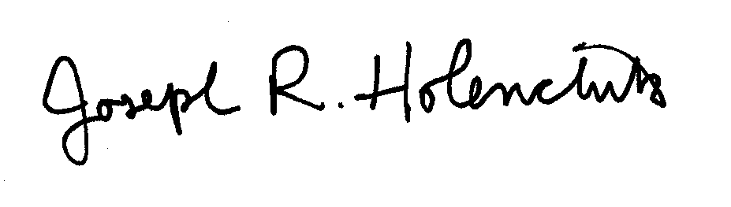

Joseph R. Holenchik

High School Principal